The Basic Principles

There are several basic principles of the KTA program. Here they are in no particular order below:
1. Severe Negatives
Severe Negatives are performed by forcing a gripper shut by pushing it against your leg or using your other hand to force close the gripper as far as possible. One then resists the opening of the gripper until the gripper either opens the hand or for a certain length of time.
2. Dynamic Thumb Strength.
Dynamic thumb strength is CRITICAL for the big crushes. Joe Kinney used a homemade Titan's type machine. At first, I thought it was static thumb strength, but in reality it's the thumb moving forward to counteract the pulling in with the fingers. Any backwards slip in the thumb and you lose leverage. So, I believe it can become a "limiting factor" in the really big crushes if you ignore it or not give it as much credit as it should get for a big time crush.
3. Beyond the Range!
What is Beyond the Range? Beyond the range is working the range of closing a gripper beyond the normal distance for when handles on the gripper touch together. That is, your hand closes up tighter than the normal gripper close. This can also be performed on a machine such as the PDA Gripantor.
4. Mind-Muscle/Hand connection (overcrushes, Beyond the Range). You MUST focus on absolute control and power when doing these.
5. High Volume, High Load
A normal grip routine would consist of a few sets of a few exercises done 1-3 times per week. High volume as defined in the KTA program is anywhere from 5-10 times a more "normal" grip routine. High load means most of the reps performed using a load higher than your goal.

6. Add weight or reps every workout (progression)
Progression is necessary in any training program. Grip training is no different. In fact, with the grippers it becomes a bit more difficult because the load is fixed for a particular gripper. You cannot just "add weight" to a gripper like you can a barbell.
7. Dedication - If you aren't going to be dedicated to this program for the first whole cycle, don't even begin.
Dedication means you do not miss a workout. You don't deviate from the plan. You don't make excuses for not training. Without dedication, this program will not work nor will any other program.
8. Determination.
You MUST be determined. Do NOT go thru the motions when doing this program. ATTACK your reps like your life depended on it. You must reach that level of mental toughness. You must destroy the gripper!!!!
9. Discipline.
Missing workouts is NOT acceptable, period. You must have the discipline to perform this program from start to end.
Without 7, 8, and 9 NO program will work. If you don't have all 3 you will be wasting your time with this program. It is definitely not for the faint hearted or those with a weak mind.

The Conditions

1. You must do only what's in the program.
Performing other grip exercises in addition to this program is not advised. If you do, all bets are off on the results. In addition, performing grip feats such as bending steel becomes very dangerous due to the highly fatigued state one will be in with this program.
2. You must be willing to do a program that most would think would be crazy (they think Kinney is crazy too or don't even believe him).
3. You must be willing to accept that you will NOT be at "full strength" all the time before the start of a workout. You MUST get over this psychological barrier!
4. You must have the next gripper up. That is, if you want to close the 3, you need a 4 or an Elite.
5. You must follow the program to the letter.
6. You must be willing to deface a gripper one level under the one you can close.
7. You must have a high pain tolerance and dedication and discipline to follow the program.
8. If you are are someone who needs plastic covers on your grippers, then this program is not for you.
9. You must remove all psychological barriers to "what's normal".
10. You must be willing to work grip 6 days a week, two workouts a day (don't worry they are short).

All Grippers Are Not Created Equal!

All grippers are not created equal! Hand grippers are cheap hardware. That's why they only cost approximately 20 dollars. One should not expect cheap hardware to be accurate. Especially when you are dealing with torsion springs. Torsion springs are not made to deflect over a great range of motion. In the application of the hand gripper, the springs DO deflect over a significant range of motion. If you ask any knowledgeable mechanical engineer who works with springs, they will tell you that with this application the springs will weaken and then equalize in strength after enough use. What does this mean? This means the hand gripper will get weaker in strength and then level off. Piedmont Design did a lot of research on torsion spring hand grippers to determine if they could be accurately measured.
Here are some of the results of PDA's research:
a. The labels T and 1-4 were always arbitrary and undocumented labels not ratings.
b. The gripper tensions have changed over the years to make them easier, but the labels were never changed.
c. All grippers to date, even with the same rating from the original spring manufacturer, or with the same rating from the gripper supplier, have significant differences in:
- torque (closure pressure for labeled grippers varies plus or minus more than originally thought)
- included angle (the angle between the handles varies from 28 to 37 degrees)
- the skew (the angle the handles shoot out sideways from the spring coil). [Note we have just realized a way to measure that angle.]
e. We are using the torsion spring in a manner outside of its design parameters, beyond the intended range of motion, thus inducing early fatigue.
f. Fatiguing 'seasons' a gripper (it gets softer based on the number of times it is fully closed).
g. Spring engineers told us that 25-50 cycles (closures) should season a gripper fully and the closure pressure should level off. Testing to date indicates that 50-100 cycles are required to season a gripper.
h. Holding a gripper fully closed (as in a vice) for any length of time has no effect on seasoning.
i. The current status of gripper fabrication, quality control and distribution means a gripster is training under the worst possible conditions. Specifically, you start out at your weakest level and the gripper is at its strongest level. You gradually get stronger as the gripper gets weaker. But, what has actually been accomplished? Try this analogy. You start out training to squat 500. You can't actually squat 500 when you start. So you load the bar to 500 and train by failing. Yes, you unquestionably get stronger. But you also have special plates that melt over time. As you get stronger the weight melts and gets lighter. But the labels don't change. Eventually you are squatting a bar that is labeled 500 pounds. But, what are you really doing?
So what does this mean to you? What it means is that all grippers are not created equal and it's hit or miss when comparing grippers or purchasing grippers that are "marked" at the same level. The markings mean nothing when comparing grippers of the same marking. There is also overlap between levels of grippers. The key in this information and The KTA Program is that you must find a gripper HARDER than your goal gripper regardless of the markings that might state otherwise. Also remember there is variation in the DYNAMICS of the closure as well. Some springs may be harder during the sweep in to closure compared to other grippers. We'll end this section by presenting actual PDA test data from Richard Sorin's grippers. Richard was the first Captain of Crush.
The PDA SOS Press Used to Test the Grippers
Page 1 of 2 - The Results of Richard Sorin's Gripper Testing
Page 2 of 2 - The Results of Richard Sorin's Gripper Testing

Gripper Technique

For maximum results with the grippers, you must find your own particular sweet spot in your hand. This takes time, patience, and practice. However, there are a few basics that apply to everyone to maximize your leverage to close that big gripper.
Let's start with the gripper itself. You should place the gripper in your hand such that the dogleg side is against your thumb pad. How do you know what side of the gripper had the dogleg? Well, here's two pictures to show you. First the side without the dogleg in figure 1.
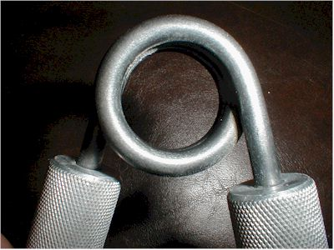
Figure 1- Gripper side with no dogleg into handle on the right
In this picture (figure 1), you can see how smoothly the spring is curved going into the handle. Now, here's the other side picture.

Gripper Technique

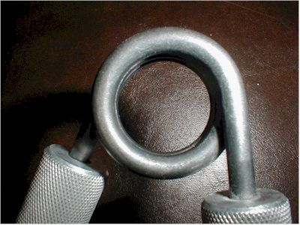
Figure 2 - Gripper side showing the dogleg going into handle on the right
Note how straight the spring goes into the handle on the right side in Figure 1 compared to Figure 2. You've found the dogleg! This handle should be placed into your thumb when placing the gripper. This makes the gripper easier to close than if you put the dogleg side on your finger tips.
The next tip is creating a thumb base. You should thrust your thumb forward at the start of the close.
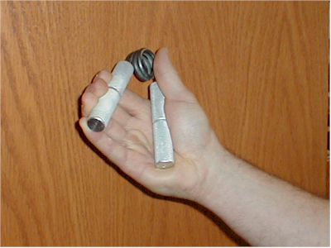
Figure 3 - Improper Start Position
Note in figure 3 how the thumb is not thrust forward and the gripper handle is back far into the hand. The leverage is poor in this position.
Gripper Technique

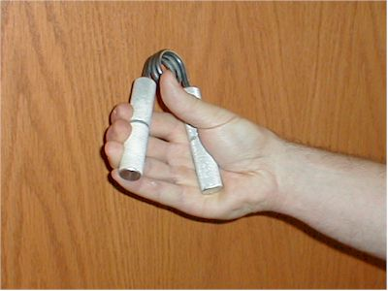
Figure 4 - Better Thumb Base for Start
In figure 4, the thumb is now forward as it should be. Although, this starting position is still not the best due to the position of the handle. Next, let's talk about handle positioning.
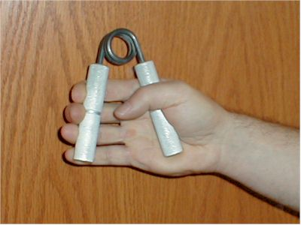
Figure 5 - Improper Handle Position on the Thumb Side
In figure 5, the improper handle position on the thumb side is again shown. The handle is too far back. The handle needs to go forward and back into the palm of the hand further. In figure 6, this shows a much more solid starting position. The back gripper handle is further towards the fingers and deeper into the palm and the thumb is forward.

Gripper Technique

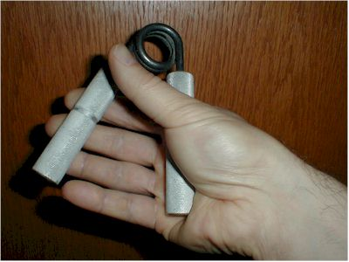
Figure 6 - Better Start Position on the Thumb Side
Next, let's talk about the height of the gripper in your hand. Figure 7 is a picture where the gripper is too high. How can you tell? Note the position of the pinky. It's basically fully on the gripper handle. For maximum leverage, you should start the gripper close such that approximately half of your pinky is off the end of the gripper. Figure 3 shows a decent start position as far as the pinky position although it could be a touch lower.
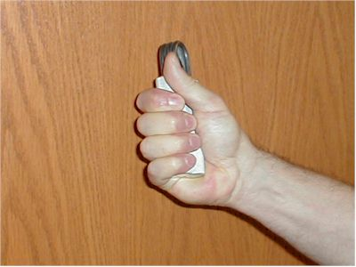
Figure 7 - Close Showing Pinky Fully on the End of the Gripper

Gripper Technique

Here's a picture of a close showing the proper placement of the pinky on the gripper for maximum leverage.
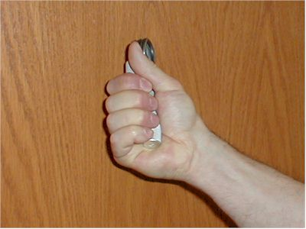
Figure 8 - Close Showing Pinky in the Proper Position for Maximum Leverage
To set the gripper, you use your opposite hand and can "pinch" the gripper handles together until you can get proper finger position as demonstrated below in figure 9. An example of proper technique can be viewed in the video clip below.
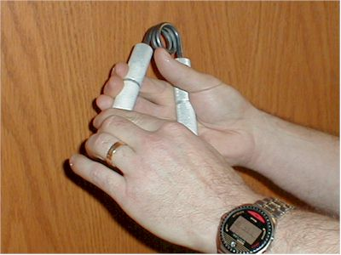
Figure 9 - Beginning of the set with the opposite hand
Here's a video clip showing the "set" of a gripper. Click the Play Button to View (Right Arrow)
Here's a video clip of me closing a vintage Beef Builder Master Gripper (they had #2 stamped on them). Note the set with the opposite hand. Note the gripper positioning in the hands and the height (pinky location) in the hands. Click the Play Button to View (Right Arrow)
Putting it all together you have:
- The dogleg side of the spring should be against your palm
- Your thumb should be thrust forward at the start
- The gripper handle on the thumb side should be pushed into your palm and forward towards your fingers as far as possible.
- Your pinky should start in a half-on half off position and end up there as well for maximum leverage.
- Use your other hand to help attain the proper set.
Again, you must practice the set and also find your particular sweet spot in your hand.
We'll leave this section with an IronMind #3 close by Captain of Crush Steve Weiner. Steve exemplifies near perfect technique!
COC Steve Weiner Mashing an IronMind #3 Gripper. Click the Play Button to View

The Overcrush

The Overcrush
The overcrush is a single repetition where you want to totally crush the metal handles together with so much force you can feel your hand bones.
The overcrush is a single rep where there is a BIG force spike when the handles first touch.
The overcrush is a single rep with pure concentration of hand and muscle.
The overcrush is not a hold. In fact, if you are barely touching the handles, push them back in again for metal on metal.
An overcrush of super high force of 3-4 seconds is better than an overcrush of 7 seconds where the handles are just "together".
After doing overcrushes with a (Beyond the Range) BTR gripper for awhile, you will feel like you are "stopping short" when you feel the handles slam together with a normal gripper.
Here's a video clip of an overcrush with a beyond the range gripper. Click the Play Button to View (Right Arrow)

The Strap Hold

The Strap Hold
Strap holds were invented by John Brookfield. You take a thin piece of material like a shoelace or a tow strap and clamp down on the end of the strap using the gripper like a pair of pliers. The strap used is normally as thin as possible. You hang weight on the other end of the strap and this provides a way to increase the resistance. Typically if you are working on a particular gripper, you should use the closest gripper to your goal gripper for strap holds (e.g., a #2 if your goal is a #3). Here's a picture of a strap hold "set" just prior to performing the strap hold and a picture in the final strap hold position.
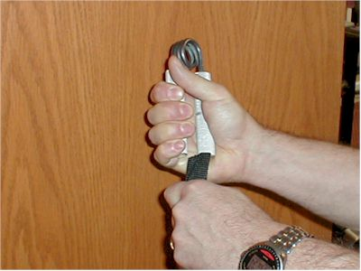
The Strap Hold "Set"
The PDA Gripster is being used for the strap hold.
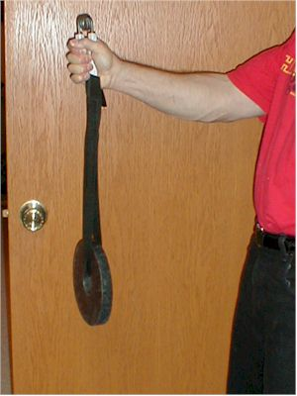
Final Strap Hold Position

Here's a video clip of a strap hold. Click the Play Button to View (Right Arrow)

Dynamic Thumb Strength

The thumb base when using the grippers is EXTREMELY important. The stronger your thumb, the better the base for the handles and the less likely you are to lose leverage due to the handle moving backwards when closing a gripper. Building the thumbs doesn't take expensive equipment. These clamps can be picked up at most hardware stores for under $3.00! Simply clamp it on a table and use either one or two thumbs on top and the index finger on the bottom and squeeze!
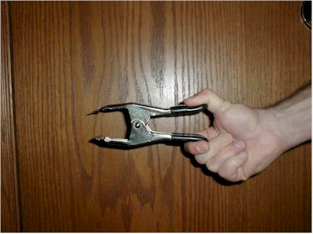
Here is a single thumb close attempt.
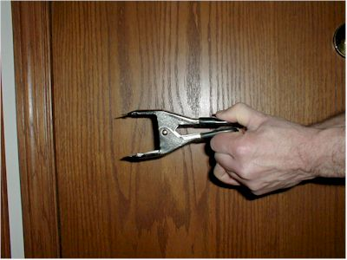
Here is a two-thumb single attempt.
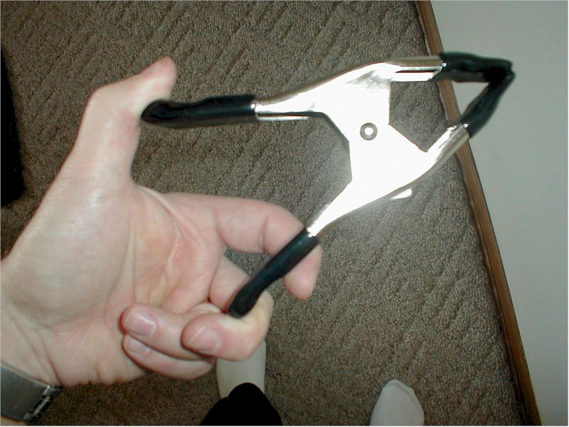
Here is a typical clamp that can be purchased at your local hardware store.

Week 1, Phase 1

This phase is comprised of negatives with a higher gripper than you want to close alternated with overcrushes with a gripper you can close and overcrush.
The negatives are NOT severe negatives. They are "smooth out" negatives. Try and cheat shut the gripper as far as you can (don't worry about how far, just as far as you can). Then try to smoothly let it out. Don't try and fight it the whole way. Just make it a smooth let out. For a smooth out negative you push the deflection as far as possible. Try and catch the force by using max force when you start to let it out and then smoothly let it out. This should take 2-3 seconds on the let out. SMOOTH as possible. It's not a hold. It's not a fight till you drop negative. If your time is 5-10 seconds you are doing a hold or severe negative.
The overcrushes...you MUST FOCUS and try to mash the steel handles together. Your force needs to be high at the initial close. Slam it shut! 5-7 seconds. If you feel your force go down in the 5-7 seconds, stop that single.
The first week's target singles is 40-50 singles. You alternate the negatives with overcrushes (OC). So, that would be 20-25 overcrushes and 20-25 negatives combined to give you 40-50 singles for the week.
For Dynamic thumb, you can use a Titan's Telegraph or buy one of the clamps shown earlier. Try and make it harder each time. You can do this by closing with two thumbs and trying to hold with one, holds for longer times, etc. If you have a Titan's Telegraph, try to increase the weight EVERY workout!
You can break up the work per day into two workouts if you desire otherwise the volume can become difficult in one workout.
One other note. If you have to struggle to get your singles, for example, can't even wrap your hand on the gripper for the negative, you are pushing too far in one workout. When doing the "sets" of singles, you should be able to pound out double the amount approximately (which is why you do the second workout in the first place). The idea is NOT to burn yourself in these workouts. You should have repetitions in the tank when you are finished.
The workouts are spaced morning or mid-day and then late afternoon or at night if you perform two workouts.
The week cycle is six days of workouts, then one day rest.
The test day leads into week 2 of Phase 1.
On the test day, warmup as as normal, and try to close the gripper you want to close for 1-2 singles. Then proceed to doing the same workouts BUT trying to significantly surpass last weeks total volume (for example, 60 this week, go for 80 next). Don't expect to see miracles in only a week with "the test". However, you just might be surprised!
It will also be better if you have some sort of normal workout (squats, or whatever) scheduled before you do it. Get your core body temperature up and a sweat going.

Phase 1 Example Workout - Intermediate

Here's a sample first week workout for someone going from a #1 to a #2 gripper. The sets and reps below are for one hand only so you should repeat the workout for each hand.
Key: 1x#3 would mean 1 single rep with the #3 gripper. 5x1 would mean 5 singles.
Remember to warmup with singles only. For an intermediate, that would consist of:
1xTrainer
1x#1
1X#2
Saturday
Grippers
1x#3 Smooth out negative
1x#1 Overcrush
1x#3 Smooth out negative
1x#1 Overcrush
1x#3 Smooth out negative
1x#1 Overcrush
Dynamic Thumb
5x1
Sunday
Grippers
1x#3 Smooth out negative
1x#1 Overcrush
1x#3 Smooth out negative
1x#1 Overcrush
1x#3 Smooth out negative
1x#1 Overcrush
Dynamic Thumb
5x1
Monday
Grippers
1x#3 Smooth out negative
1x#1 Overcrush
1x#3 Smooth out negative
1x#1 Overcrush
1x#3 Smooth out negative
1x#1 Overcrush
Dynamic Thumb
5x1
Tuesday
Grippers
1x#3 Smooth out negative
1x#1 Overcrush
1x#3 Smooth out negative
1x#1 Overcrush
1x#3 Smooth out negative
1x#1 Overcrush
1x#3 Smooth out negative
1x#1 Overcrush
Dynamic Thumb
5x1
Wednesday
Grippers
1x#3 Smooth out negative
1x#1 Overcrush
1x#3 Smooth out negative
1x#1 Overcrush
1x#3 Smooth out negative
1x#1 Overcrush
1x#3 Smooth out negative
1x#1 Overcrush
Dynamic Thumb
7x1
Thursday
Grippers
1x#3 Smooth out negative
1x#1 Overcrush
1x#3 Smooth out negative
1x#1 Overcrush
1x#3 Smooth out negative
1x#1 Overcrush
1x#3 Smooth out negative
1x#1 Overcrush
1x#3 Smooth out negative
1x#1 Overcrush
Dynamic Thumb
7x1
Friday
Rest Day
Overview
Total Volume for Week: 44 singles. Target was 40-50 singles.
Week 2 Target is 70-80 singles. You merely add more volume each day to increase to the target. To hit this mark, you need 12-13 singles per workout.
Week 3 Target is 90-100 singles. To hit this mark, you need 15-16 singles per workout.

Phase 1 Example Workout - Advanced

Here's a sample first week workout for someone going from a #2 to a #3 gripper. The sets and reps below are for one hand only so you should repeat the workout for each hand.
Key: 1x#4 would mean 1 single rep with the #4 gripper. 5x1 would mean 5 singles.
Remember to warmup with singles only. For an advanced grip trainee that would consist of:
1xTrainer
1x#1
1X#2
1X#3
Saturday
Grippers
1x#4 Smooth out negative
1x#2 Overcrush
1x#4 Smooth out negative
1x#2 Overcrush
1x#4 Smooth out negative
1x#2 Overcrush
Dynamic Thumb
5x1
Sunday
Grippers
1x#4 Smooth out negative
1x#2 Overcrush
1x#4 Smooth out negative
1x#2 Overcrush
1x#4 Smooth out negative
1x#2 Overcrush
Dynamic Thumb
5x1
Monday
Grippers
1x#4 Smooth out negative
1x#2 Overcrush
1x#4 Smooth out negative
1x#2 Overcrush
1x#4 Smooth out negative
1x#2 Overcrush
Dynamic Thumb
5x1
Tuesday
Grippers
1x#4 Smooth out negative
1x#2 Overcrush
1x#4 Smooth out negative
1x#2 Overcrush
1x#4 Smooth out negative
1x#2 Overcrush
1x#4 Smooth out negative
1x#2 Overcrush
Dynamic Thumb
5x1
Wednesday
Grippers
1x#4 Smooth out negative
1x#2 Overcrush
1x#4 Smooth out negative
1x#2 Overcrush
1x#4 Smooth out negative
1x#2 Overcrush
1x#4 Smooth out negative
1x#2 Overcrush
Dynamic Thumb
7x1
Thursday
Grippers
1x#4 Smooth out negative
1x#2 Overcrush
1x#4 Smooth out negative
1x#2 Overcrush
1x#4 Smooth out negative
1x#2 Overcrush
1x#4 Smooth out negative
1x#2 Overcrush
1x#4 Smooth out negative
1x#2 Overcrush
Dynamic Thumb
7x1
Friday
Rest Day
Overview
Total Volume for Week: 44 singles. Target was 40-50 singles.
Week 2 Target is 70-80 singles. You merely add more volume each day to increase to the target. To hit this mark, you need 12-13 singles per workout.
Week 3 Target is 90-100 singles. To hit this mark, you need 15-16 singles per workout.

Phase 1, Week 2

Ok, now in week two we want to use the cut grippers for overcrushes (beyond the range). See the next page for a description of the beyond the range gripper. The overcrushes should be in the 7-10 sec range. If the handles don't quite touch the full time, force it in to shut, if it comes apart a hair, force it in again...continue to do so if necessary the full time. Again, MAX FORCE with the beyond the range gripper is a must.
Volume for week two should be +20 singles to +30 (whatever you can handle) from week 1. Volume should be up around 70-80 singles.

Beyond The Range (BTR)

Shown in figure 1 we have a cut (filed) #2 gripper. Contrary to popular opinion, it will NOT severely weaken the gripper.
I took a file and filed the edge down on one of the handles (only do this on one handle). You will want it so the range is such that your fingers just start to hit the other side of your hand when you close the gripper.
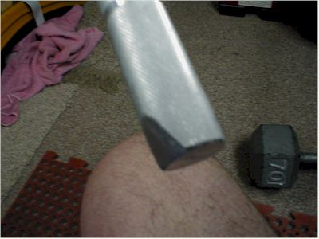
Figure 1 - Filed #2 Gripper Handle
Figure 2 - Top View of a Filed #2 Gripper
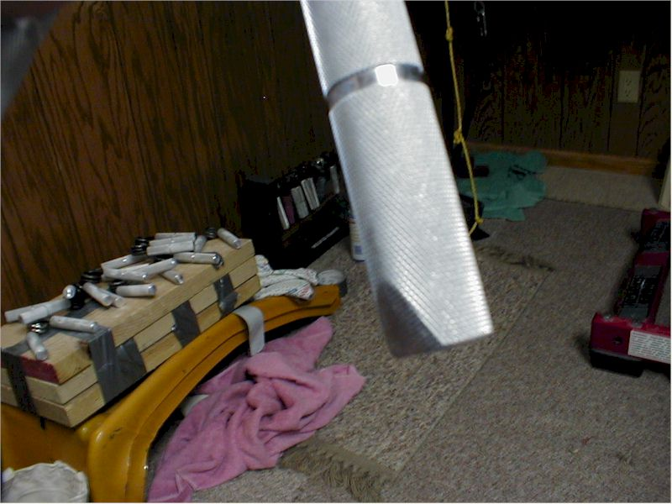
Figure 3 - Another View of the Filed #2 Gripper Handle
I can close the #3, so I use a cut #2 for overcrushes. However, I really need a beef builder master cut, but don't have one. So use that as your guideline for which one to use. If you can close a 2 for reps, I would use a cut #2 for overcrushes beyond the range.

Phase 1, Week 3

For week 3, continue to add volume until you reach the 95-100 total singles level for the week. Next week is a back down week.

Phase 1, Week 4 - Back Down Week

Start by warmups to 1-3 attempts at your goal gripper. Then, one good smooth out negative with the higher gripper. Dynamic thumb strength (3-6 singles). Then, 2 overcrushes with the beyond the range gripper.
Add in one extra day rest somewhere in the "back down week".

Phase 2, Week 1

Phase 2 is much like Phase 1 with two exceptions.
We now do not do smooth outs with the gripper above what you are trying to close. We do 5 second Negative Crushes instead. What is a Negative Crush (NC)? See the next page to find out.
We will inject Strap Holds (4-7 seconds). Always try and increase the weight you are using for Strap Holds. Microload if you have to.
We start at lower volume again - target 50-60 singles in the week.
Instead of alternating the negatives with just overcrushes, you alternate with strap holds AND overcrushes.
Dynamic thumb is still included.
You can do one or two workouts to split the volume. Your choice.
There is also a new option. Strapholds with a cut gripper. You can do your strapholds that way if you have the right cut gripper.
Also, if you are close to your goal gripper, during your warmups do an attempt at your goal gripper as your last warmup.
Same cycle. 6 days on, 1 day off.

The Negative Crush

I think most people who tried Kinney's concepts did NOT do the severe negatives properly. I know I didn't.
The severe negative is not a "fight to hold" from opening.
It's a negative crush! (My new term for it).
Forget about the mindset of fighting the gripper from opening.
The mindset has to be: I am going to CLOSE this gripper and the opening is merely a side effect of you not being strong enough to close it.
You have to CRUSH it! The whole time! It is NOT a hold. It should be like you are trying to mash it. The force should be positive and the opening is just a side effect.
You have to concentrate on CLOSING it NOT holding it. Repeat: It's a different mind set.
CRUSH CRUSH CRUSH...FOCUS FOCUS FOCUS.
Forget about the opening. CRUSH it!
The difference in how affective the negative will be is like night and day.

Phase 2 Example Workout - Intermediate

Here's a sample first week workout for someone going from a #1 to a #2 gripper. The sets and reps below are for one hand only so you should repeat the workout for each hand.
Key: 1x#3 would mean 1 single rep with the #3 gripper. 5x1 would mean 5 singles.
Remember to warmup with singles only. For an intermediate grip trainee that would consist of:
1xTrainer
1x#1
1X#2
Saturday
Grippers
1x#3 Negative Crush
1x#1 Overcrush
1x#3 Negative Crush
1x#1 Strap hold (5-7 seconds)
1x#3 Negative Crush
1x#1 Overcrush
Dynamic Thumb
5x1
Sunday
Grippers
1x#3 Negative Crush
1x#1 Overcrush
1x#3 Negative Crush
1x#1 Strap hold (5-7 seconds)
1x#3 Negative Crush
1x#1 Overcrush
Dynamic Thumb
5x1
Monday
Grippers
1x#3 Negative Crush
1x#1 Overcrush
1x#3 Negative Crush
1x#1 Strap hold (5-7 seconds)
1x#3 Negative Crush
1x#1 Overcrush
Dynamic Thumb
5x1
Tuesday
Grippers
1x#3 Negative Crush
1x#1 Overcrush
1x#3 Negative Crush
1x#1 Strap hold (5-7 seconds)
1x#3 Negative Crush
1x#1Overcrush
1x#3 Negative Crush
1x#1 Strap hold (5-7 seconds)
Dynamic Thumb
5x1
Wednesday
Grippers
1x#3 Negative Crush
1x#1 Overcrush
1x#3 Negative Crush
1x#1 Strap hold (5-7 seconds)
1x#3 Negative Crush
1x#1 Overcrush
1x#3 Negative Crush
1x#1 Strap hold (5-7 seconds)
Dynamic Thumb
7x1
Thursday
Grippers
1x#3 Negative Crush
1x#1 Overcrush
1x#3 Negative Crush
1x#1 Strap hold (5-7 seconds)
1x#3 Negative Crush
1x#1 Overcrush
1x#3 Negative Crush
1x#1 Strap hold (5-7 seconds)
1x#3 Negative Crush
1x#1 Overcrush
Dynamic Thumb
7x1
Friday
Rest Day
Overview
Total Volume for Week: 44 singles. Target was 40-50 singles.
Week 2 Target is 70-80 singles. You merely add more volume each day to increase to the target. To hit this mark, you need 12-13 singles per workout.
Week 3 Target is the same as Week 2.

Phase 2 Example Workout - Advanced

Here's a sample first week workout for someone going from a #2 to a #3 gripper. The sets and reps below are for one hand only so you should repeat the workout for each hand.
The smooth out negative is now replaced with the negative crush in this phase. We also are adding strap holds. The negative crushes are 5 seconds in length.
Key: 1x#4 would mean 1 single rep with the #4 gripper. 5x1 would mean 5 singles.
Remember to warmup with singles only. For an advanced grip trainee that would consist of:
1xTrainer
1x#1
1X#2
1X#3
Saturday
Grippers
1x#4 Negative Crush
1x#2 Overcrush
1x#4 Negative Crush
1x#2 Strap hold (5-7 seconds)
1x#4 Negative Crush
1x#2 Overcrush
Dynamic Thumb
5x1
Sunday
Grippers
1x#4 Negative Crush
1x#2 Overcrush
1x#4 Negative Crush
1x#2 Strap hold (5-7 seconds)
1x#4 Negative Crush
1x#2 Overcrush
Dynamic Thumb
5x1
Monday
Grippers
1x#4 Negative Crush
1x#2 Overcrush
1x#4 Negative Crush
1x#2 Strap hold (5-7 seconds)
1x#4 Negative Crush
1x#2 Overcrush
Dynamic Thumb
5x1
Tuesday
Grippers
1x#4 Negative Crush
1x#2 Overcrush
1x#4 Negative Crush
1x#2 Strap hold (5-7 seconds)
1x#4 Negative Crush
1x#2 Overcrush
1x#4 Negative Crush
1x#2 Strap hold (5-7 seconds)
Dynamic Thumb
5x1
Wednesday
Grippers
1x#4 Negative Crush
1x#2 Overcrush
1x#4 Negative Crush
1x#2 Strap hold (5-7 seconds)
1x#4 Negative Crush
1x#2 Overcrush
1x#4 Negative Crush
1x#2 Strap hold (5-7 seconds)
Dynamic Thumb
7x1
Thursday
Grippers
1x#4 Negative Crush
1x#2 Overcrush
1x#4 Negative Crush
1x#2 Strap hold (5-7 seconds)
1x#4 Negative Crush
1x#2 Overcrush
1x#4 Negative Crush
1x#2 Strap hold (5-7 seconds)
1x#4 Negative Crush
1x#2 Overcrush
Dynamic Thumb
7x1
Friday
Rest Day
Overview
Total Volume for Week: 44 singles. Target was 40-50 singles.
Week 2 Target is 70-80 singles. You merely add more volume each day to increase to the target. To hit this mark, you need 12-13 singles per workout.
Week 3 Target is the same as Week 2.

Phase 2, Week 2

Increase the volume from Week 1 doing the same workout for week 2.
Same cycle. 6 days on, 1 day off.

Phase 2, Week 3

For week 3, keep the volume the same and add an extra day of rest somewhere in the week.
Also, the negative crushes (NC's) you just need to maintain which means 1-2 per workout.
Focus on your goal gripper. So alternate goal gripper with the strap holds and overcrushes.
One workout per day only.
Focus on adding weight to the strap holds.
When you do your goal gripper, force it in with your other hand a couple times to make it touch (that is, IF you miss it).

Phase 2, Week 4

The same as week 2.
Increase volume by approximately 10-15 singles.

Phase 3, The Peaking Phase

Phase 3 is the peaking phase. For you #3 closers, this is the phase where you will work to be witnessed and certified. For others, this is the phase to show off and display all your hard work that you put into the program.
The focus will be on closing your goal gripper in your workouts. However, we will not forget what got us to this point and will include stapholds, NC's, and overcrushes. This phase is two weeks long. Each week's workouts are the same and workouts are now performed every other day. So, the rest is increased.
Intermediate and Advanced workout examples are provided in the next pages. They are self-explanatory.

Phase 3 Example Workout - Intermediate

The workouts in Phase 3 are now performed every other day. Week 1 and Week 2 of Phase 3 are identical so merely repeat this workout for Week 2.
1xTrainer
1x#1
1X#1
Saturday
Grippers
1x#2
1x#2
1x#2
1x#2
1x#2
1x#2
1x#2
1x#2
1x#3 Negative Crush
1x#3 Negative Crush
1x Straphold
1x Overcrush
1x Straphold
1x Overcrush (do this overcrush for 15 seconds and even if the gripper handles separate during this time, keep going until the time is reached)
Dynamic Thumb
5x1
Sunday
Rest
Monday
Grippers
1x#2
1x#2
1x#2
1x#2
1x#2
1x#2
1x#2
1x#2
1x#3 Negative Crush
1x#3 Negative Crush
1x Straphold
1x Overcrush
1x Straphold
1x Overcrush (do this overcrush for 15 seconds and even if the gripper handles separate during this time, keep going until the time is reached)
Dynamic Thumb
5x1
Tuesday
Rest
Wednesday
Grippers
1x#2
1x#2
1x#2
1x#2
1x#2
1x#2
1x#2
1x#2
1x#2
1x#3 Negative Crush
1x#3 Negative Crush
1x Straphold
1x Overcrush
1x Straphold
1x Overcrush (do this overcrush for 15 seconds and even if the gripper handles separate during this time, keep going until the time is reached)
Dynamic Thumb
5x1
Thursday
Rest
Friday
Grippers
1x#2
1x#2
1x#2
1x#2
1x#2
1x#2
1x#2
1x#2
1x#2
1x#2
1x#3 Negative Crush
1x#3 Negative Crush
1x Straphold
1x Overcrush
1x Straphold
1x Overcrush (do this overcrush for 15 seconds and even if the gripper handles separate during this time, keep going until the time is reached)
Dynamic Thumb
5x1
Saturday
Rest
Repeat the alternating of workout/rest day for the next week as well.

Phase 3 Example Workout - Advanced

The workouts in Phase 3 are now performed every other day. Week 1 and Week 2 of Phase 3 are identical so merely repeat this workout for Week 2.
1xTrainer
1x#1
1X#1
1x#2
Saturday
Grippers
1x#3
1x#3
1x#3
1x#3
1x#3
1x#3
1x#3
1x#3
1x#4 Negative Crush
1x#4 Negative Crush
1x Straphold
1x Overcrush
1x Straphold
1x Overcrush (do this overcrush for 15 seconds and even if the gripper handles separate during this time, keep going until the time is reached)
Dynamic Thumb
5x1
Sunday
Rest
Monday
Grippers
1x#3
1x#3
1x#3
1x#3
1x#3
1x#3
1x#3
1x#3
1x#4 Negative Crush
1x#4 Negative Crush
1x Straphold
1x Overcrush
1x Straphold
1x Overcrush (do this overcrush for 15 seconds and even if the gripper handles separate during this time, keep going until the time is reached)
Dynamic Thumb
5x1
Tuesday
Rest
Wednesday
Grippers
1x#3
1x#3
1x#3
1x#3
1x#3
1x#3
1x#3
1x#3
1x#3
1x#4 Negative Crush
1x#4 Negative Crush
1x Straphold
1x Overcrush
1x Straphold
1x Overcrush (do this overcrush for 15 seconds and even if the gripper handles separate during this time, keep going until the time is reached)
Dynamic Thumb
5x1
Thursday
Rest
Friday
Grippers
1x#3
1x#3
1x#3
1x#3
1x#3
1x#3
1x#3
1x#3
1x#3
1x#3
1x#4 Negative Crush
1x#4 Negative Crush
1x Straphold
1x Overcrush
1x Straphold
1x Overcrush (do this overcrush for 15 seconds and even if the gripper handles separate during this time, keep going until the time is reached)
Dynamic Thumb
5x1
Saturday
Rest
Repeat the alternating of workout/rest day for the next week as well.

Conclusion

Congratulations! If you made through the KTA program, you will have significantly increased your crushing strength. You can continue with this program (after taking another back down week with at LEAST two days rest) or you can take what information you have gathered and tweak the KTA program based on your individual needs and what's best for you. For example, Heath Sexton, who has come within a whisper of closing an IronMind #4 gripper went back in Phase 2 with a few twists. However, remember to always try and add load and or volume every workout.
Don't lose track of the "planning" involved with increasing load or volume. It's easy to get lost in your workouts and they become nothing more but a repeat of the last one without trying to significantly get stronger! Good luck.

Glossary

Beyond The Range - Closing a gripper beyond the normal close range so the hand close tighter. This is usually done by shaving the inside of a gripper or grip machine handle.
COC - Certified Captain of Crush. A person who has been officially witnessed closing an IronMind #3 gripper.
Close - The last inch of to closure of a gripper.
Dogleg - The slight straightening of the curve of the torsion spring into the handle of a gripper.
Dynamic Thumb Strength - Thumb strength where the thumb is moving - in a forward direction towards the fingers.
Gripster - Piedmont Design's straphold device.
Joe Kinney - The first and only man to close IronMind's #4 gripper.
John Brookfield - A grip strength legend and one of the strongest gripmasters of all time.
Negative Crush - Forcing shut a big gripper with the assistance of the opposite hand or a leg and instead of just resisting the gripper when it opens one tries to actually close the gripper.
Overcrush - The closing of a gripper with extreme force and holding this force when the handles meet so it seems you actually can feel the bones in your hand.
Richard Sorin - A grip strength legend and one of the strongest gripmasters of all time. The first official Captain of Crush.
Set - The use of the opposite hand to position the gripper to find the sweet spot in the hand for maximum closure leverage.
Severe Negative - Forcing shut a big gripper with the assistance of the opposite hand or a leg and resisting the opening all the way until the gripper finally "wins".
Smooth Out Negative - Forcing shut a big gripper with the assistance of the opposite hand or a leg and smoothly letting the gripper out.
Sweep - The part of the gripper closure from the set to approximately one inch of closure.
Straphold - Using a gripper as a pair of pliers on a thin piece of material and attaching a weight to the other end of the material. Used to work the last bit of the close.
T, #1, #2, #3, #4 - The torsion grippers offered by IronMind Enterprises.

